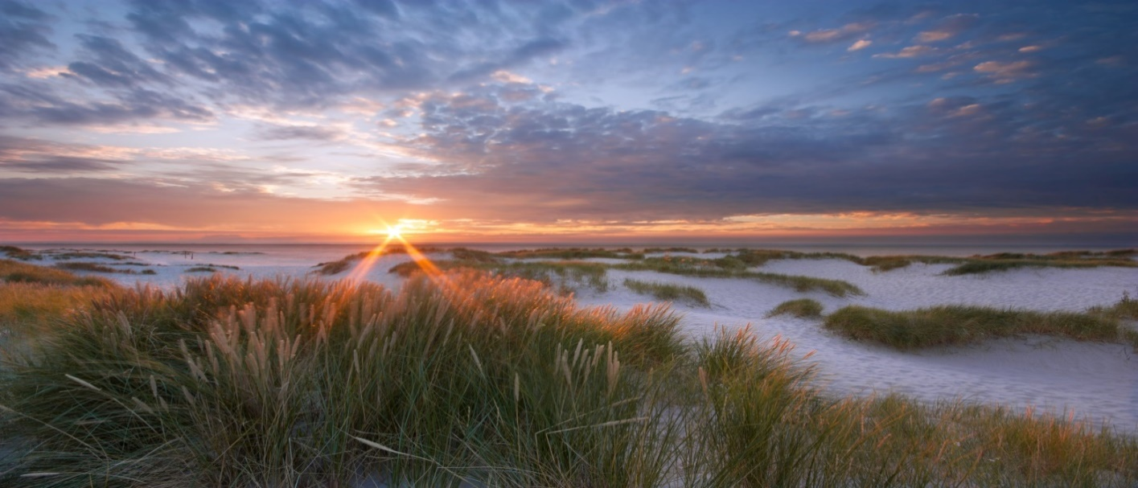

PROWAD LINK – Forum

2nd PROWAD LINK Forum
Virtual Wadden Sea Conference
10:00 – 12:30
2 November 2021
Draft Programme

9:45 Start of Virtual Wadden Sea
10:00 Welcome

10:30 Protect and Prosper – Main achievements of PROWAD LINK and outlook 2022 [document in advance]

10:45 Introduction to thematic virtual rooms:
- Brand activation – How to engage and use the World Heritage brand at local level?
- Trilateral visitor survey in Corona times: First result. – What does this mean for entrepreneurs and decision makers?
- World Heritage Partnership Hub –What projects are needed to better link World Heritage protection and sustainable regional development? How to link with local projects?
- North Sea Innovation Challenge – Sustainable entrepreneurship and innovative ideas for the future. How can I participate?

11:30 Coffee break with discussions (interactive)

12:00 Summary of meeting

12:30 End of meeting

To register, please send an email to marencic@waddensea-secretariat.org

