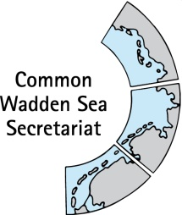
DRAFT AGENDA v0.2
Expert group Climate Change Adaptation
(EG-C 16)
31 March 2023
online

- Opening of the Meeting and adoption of the Agenda
The meeting will be opened by the Chairperson at 09:30 on 31 March 2023.
Proposal: Adopt the draft agenda of the meeting

- Adoption of the draft summary record
Document: EG-16/2-SR-EG-C15
Proposal: Adopt the draft Summary Record of EG-C 15.

- Announcements
Announcements of participants. Proposal: Note the information.

- Activities and Work plan 2023 – 2026, including MANABAS Coast
Document: EG-C16-4 Work plan and ToR
Discuss work plan and ToR of EG-C, including activities within the Interreg MANABAS Coast project
Proposal: Agree on proposal, TOR and work plan

- Any Other Business and next meeting
Any other business
Next meeting.

- Closing
The meeting will be closed no later than 12:00 on 31 March 2023.

