NETWORK GROUP
Sustainable Tourism
NG-ST 26

ZOOM meeting

10 February 2021

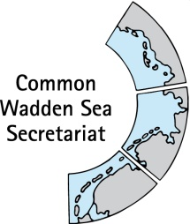
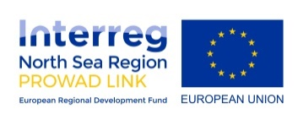

_________________________________________________________________________

Agenda Item: 9

Subject: Single integrated management plan (SIMP)

Document No. NG-ST 26-4

Date: 10 February 2021

Submitted by: CWSS
___________________________________________________________________________________

The Leeuwarden Declaration 2018 includes the task to develop a single integrated management plan for the Wadden Sea World Heritage (SIMP) as requested by the WH Committee in 2014. The content of the SIMP will reflect the current priorities of the Trilateral Wadden Sea Cooperation (TWSC) and will focus on overarching issues needed to be managed with priority and in a consistent way to maintain the OUV and the integrity (Annex 1 of the Leeuwarden Declaration).
The SIMP addresses five key topics, selected as the result of a process endorsed by WSB 29 (WSB 29/5.1/1 Status Report SIMP) that included the selection criteria submitted in Annex 1 of the Leeuwarden Declaration, the recommendations of the managers, the statement of OUV and the prioritization by TG-WH 29. In October 2019, the WSB 30 endorsed fisheries, tourism, shipping, and renewable energy and energy from oil and gas as key topics for the SIMP (WSB30 5.1-2 SIMP status report.pdf).

NG-ST 25 was introduced and asked to support the qualitative analysis to identify how potential or existing impacts from touristic activities affect the World Heritage Outstanding Universal Value, as well as opportunities or positive effects from tourism that benefit the OUV. The meeting discussed their role in confirming or identifying further (potential) impacts of touristic activities as well as (potential) opportunities and positive effects of touristic activities on the Outstanding Universal Value (OUV) of the Wadden Sea. The Meeting agreed on the following next steps: 1) to complete the list of impacts and reorganise them according to their type using existing information, 2) to further inform the listed impacts with studies specific to the Wadden Sea, 3) to conduct the assessment of impacts from touristic activities on the OUV key values with nature conservation experts. The trends of the touristic activities can be informed by NG-ST, and 4) to identify the measures that are in place in the different countries to address the impacts and assess gaps.

In order to fulfil in the best way possible, the above listed next steps, a group of scientists will be engaged (in synergy to the QSR Thematic Report) and preliminary results regarding the rapid assessment of impacts from touristic activities on the OUV key values and identification of opportunities will be shared among the relevant TWSC groups and organisations to enrich according to their expertise.

Proposal

The meeting is proposed to note the information.

