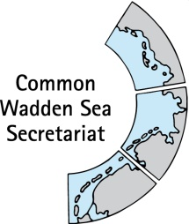

TASK GROUP
World Heritage
TG-WH 37

12 - 13 July 2022
Virtual Meeting

_________________________________________________________________________

Agenda Item: 3

Subject: Announcements National Park Authority Lower Saxony

Document No. TG-WH 37/3/2

Date: 11 July 2022

Submitted by: National Park Authority Lower Saxon Wadden Sea

_________________________________________________________________________

Wadden Sea World Heritage Anniversary

This year, local residents in the Lower Saxony's Wadden Sea region were again invited by the National Park Authority to take part in a free guided tour to mark the anniversary of the Wadden Sea World Heritage’s inscription to the World Heritage List.
Almost 300 local people took part in a tour of the mudflats between 24 and 26 June 2022. The offer of the National Park Authority in cooperation with National Park guides included 45 events at 20 locations along the coast of Lower Saxony and on the islands.

Proposal

The meeting is proposed to note the announcements.

